**PRACTICAL – 09**

**AIM:** Create a Struts application

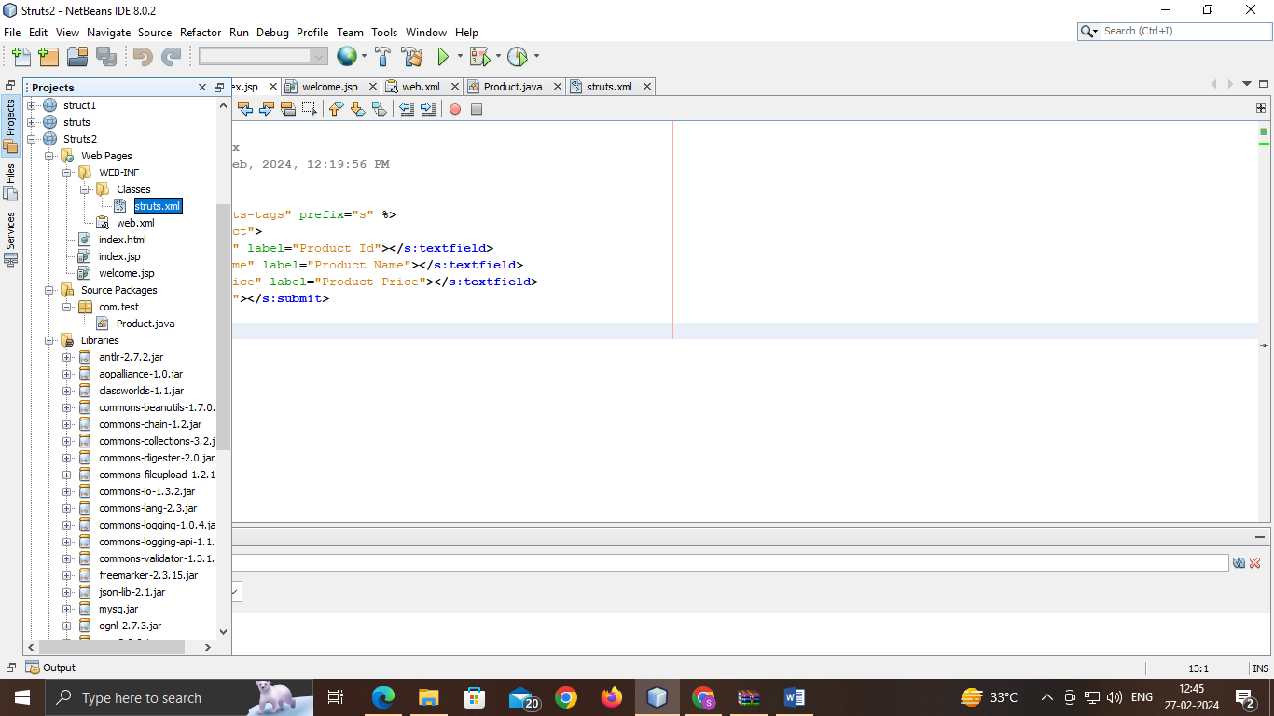

**index.html:**

<html>

<head>

<title>TODO supply a title</title>

<meta charset="UTF-8">

<meta name="viewport" content="width=device-width, initial-scale=1.0">

</head>

<body>

<div>TODO write content</div>

</body>

</html>

**index.jsp:**

<%--

Document : index

Created on : 27 Feb, 2024, 12:19:56 PM

Author : ckt

--%>

<%@ taglib uri="/struts-tags" prefix="s" %>

<s:form action="product">

<s:textfield name="id" label="Product Id"></s:textfield>

<s:textfield name="name" label="Product Name"></s:textfield>

<s:textfield name="price" label="Product Price"></s:textfield>

<s:submit value="save"></s:submit>

</s:form>

**welcome.jsp:**

<%@ taglib uri="/struts-tags" prefix="s" %>

Product Id:<s:property value="id"/><br/>

Product Name:<s:property value="name"/><br/>

Product Price:<s:property value="price"/><br/>

**web.xml:**

<?xml version="1.0" encoding="UTF-8"?>

<web-app xmlns="http://xmlns.jcp.org/xml/ns/javaee"

xmlns:xsi="http://www.w3.org/2001/XMLSchema-instance"

xsi:schemaLocation="http://xmlns.jcp.org/xml/ns/javaee http://xmlns.jcp.org/xml/ns/javaee/web-app_3_1.xsd"

version="3.1">

<session-config>

<session-timeout>

30

</session-timeout>

</session-config>

<filter>

<filter-name>struts2</filter-name>

<filter-class>

org.apache.struts2.dispatcher.ng.filter.StrutsPrepareAndExecuteFilter

</filter-class>

</filter>

<filter-mapping>

<filter-name>struts2</filter-name>

<url-pattern>/*</url-pattern>

</filter-mapping>

</web-app>

**Product.java:**

package com.test;

public class Product {

private int id;

private String name;

private float price;

public int getId()

{ return id; }

public void setId(int id)

{ this.id = id; }

public String getName()

{ return name; }

public void setName(String name)

{ this.name = name; }

public float getPrice() {

return price;

}

public void setPrice(float price) {

this.price = price;

}

public String execute(){

return "success";

}

}

**struts.xml:**

<?xml version="1.0" encoding="UTF-8" ?>

<!DOCTYPE struts PUBLIC "-//Apache Software Foundation//DTD Struts

Configuration 2.1//EN" "http://struts.apache.org/dtds/struts-2.1.dtd">

<struts>

<package name="default" extends="struts-default">

<action name="product" class="com.test.Product">

<result name="success">welcome.jsp</result>

</action>

</package>

</struts>

**OUTPUT:**

